
SRM Institute of Science and Technology
Mode of Exam
OFFLINE
College of Engineering and Technology
School of Computing
DEPARTMENT OF COMPUTATIONAL INTELLIGENCE
SRM Nagar, Kattankulathur – 603203, Chengalpattu District, Tamilnadu
Academic Year: 2022-23 (EVEN)
Test: CLAT-2 Date: 04.04.2023
Course Code & Title: 18AIC209T Foundation of Metric Spaces Duration: 1 Hour
Year & Sem: II Year & IV Semester Max. Marks: 25 Marks
Course Articulation Matrix: (to be placed)
Course Learning Outcomes (CO): |  |  |  |  |  | At the end of this course, learners will be able to:
CO-1 : |  | Discover whether examples of metric spaces are complete using Cauchy sequences
CO-3 |  | Understand iterative processes on general spaces
CO-3 |  | Can apply principles and algorithms to evaluate models generated from data
Program Learning Outcomes (PLO)
1 | 2 |  | 3 | 4 | 5 |  | 6 | 7 | 8 | 9 | 10 | 11 | 12 | PSO
Engineering Knowledge | Problem Analysis |  | Design & Development | Analysis, Design, Research | Modern Tool Usage |  | Society & Culture | Environment & Sustainability | Ethics | Individual &Team Work | Communication | Project Mgt. & Finance | Life Long Learning | PSO - 1 | PSO - 2 | PSO – 3
3 | 2 |  | 2 | 3 | - |  | - | 1 | - | - | 3 | 2 | 2 | 2 | 2 | 2
3 | 3 |  | 3 | 2 | 3 |  | - | 2 | 1 | - | 3 | 3 | 2 | 2 | 2 | 2
3 | 3 |  | 2 | 3 | 3 |  | 2 | 2 | 2 | 1 | 3 | 2 | - | 2 | 2 | 2

Part - A (10 x 1 = 10 Marks)
Instructions: Answer all
Q. No | Question | Marks | BL | CO | PO | PI Code
1 | A bijective map A : X → Y is open if and only if :  (a) A : X → Y is invertible.  (b) A : X → Y is bounded.  (c) A−1 : Y → X is bounded.  (d) A−1 : Y → X is open. | 1 | 1 | 2 | 1,2 | 1.1.1
2 | Pick the incorrect statement:  (a) Every linear subspace of a normed space is convex.  (b) Every ball in a normed space is convex.  (c) Intersection of two convex sets is convex.  (d) Union of two convex sets is convex. | 1 | 1 | 2 | 1,2 | 1.1.2
3 | Let X be an inner product space. Then the orthogonal complement of {0} is:  (a) X  (b) {0}  (c) X\{0}  (d) X⊥ | 1 | 1 | 2 | 1 | 2.1.1
4 | A Hausdorff space that is totally disconnected.  (a) Discrete topological space  (b) Indiscrete topological space  (c) finite set  (d) None of the above | 1 | 1 | 2 | 1,2 | 2.1.3
5 | Let X be any infinite topological space and τ be the family consisting of ϕ and complement of finite subset of X. Then tau is called  (a) Co-finite topology  (b) Co-complement topology  (c) No solution  (d) None of the above | 1 | 1 | 2 | 2 | 2.1.3
6 | In a discrete space (X, d), every subset is ____________  (a) Open ball  (b) Bounded set  (c) Open set  (d) Closed ball | 1 | 1 | 3 | 1 | 1.4.1
7 | A finite Cartesian product of a connected space is ____________  (a) Closed  (b) Separated  (c) Hausdorff  (d) Connected | 1 | 1 | 3 | 1 | 1.1.1
8 | The space [0, 1]ω with the product topology is ____________  (a) Bounded  (b) Unbounded  (c) Finite  (d) Metrizable | 1 | 1 | 3 | 1 | 2.1.1
9 | Which of the following is a compact set?  (a) (0, 1)  (b) [0, 1]  (c) (1, 1)  (d) (0, 0) | 1 | 1 | 3 | 1 | 1.2.2
10 | Let (X, τ ) be s topological space, where X = {a, b, c}. Then which of the following is a topology on X.  (a) τ1 = {ϕ, X}  (b) τ2 = {ϕ, X, a}  (c) τ3 = {ϕ, X, {a}, {a, b}}  (d) All of the above | 1 | 1 | 3 | 1,2 | 1.1.1
Part – B
( 3 x 5 = 15 Marks)
Instructions: Answer any 3
11 | Explain the notations used in metric space maps. | 5 | 2 | 3 | 1,2 | 2.4.1
12 | Prove that every open ball in a metric space (X,d) is an open set in (X,d). What about the converse? Justify. | 5 | 3 | 3 | 1,2 | 2.3.1
13 | Describe the Cauchy sequence and complete space. | 5 | 2 | 2 | 1,2 | 2.3.2
14 | Let (X, τ ) be a topological space and A ⊆ X a subset. Describe the interior of A (denoted int(A)) and the closure of A (denoted cl(A)). | 5 | 3 | 2 | 1,2 | 1.1.2

*Performance Indicators are available separately for Computer Science and Engineering in AICTE examination reforms policy.
Course Outcome (CO) and Bloom’s level (BL) Coverage in Questions

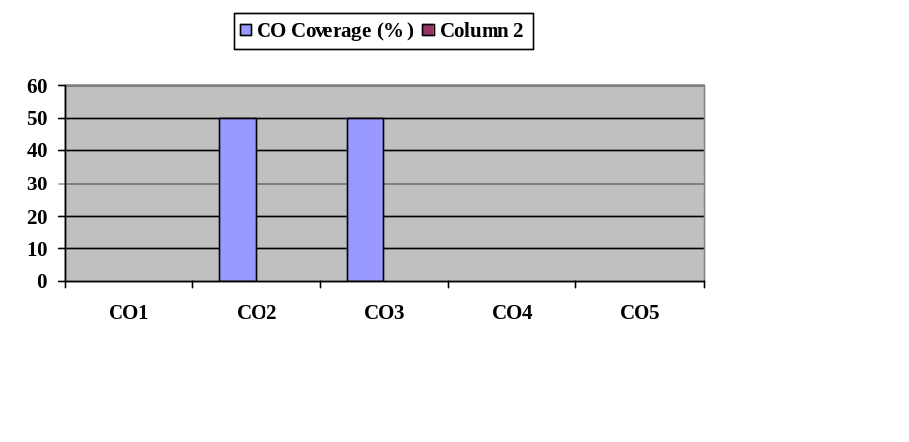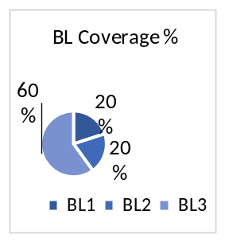
Approved by the Audit Professor/Course Coordinator

